**4.1 Learning Objectives**

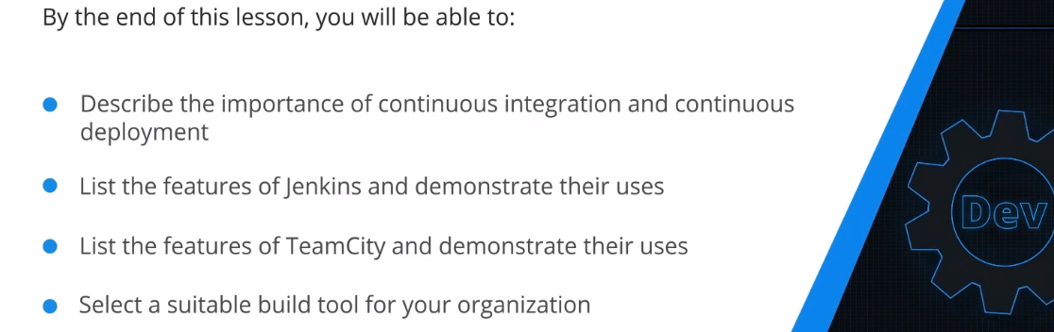

**4.2 Overview and Importance of CI and CD**

Overview of Continiuous Integration:

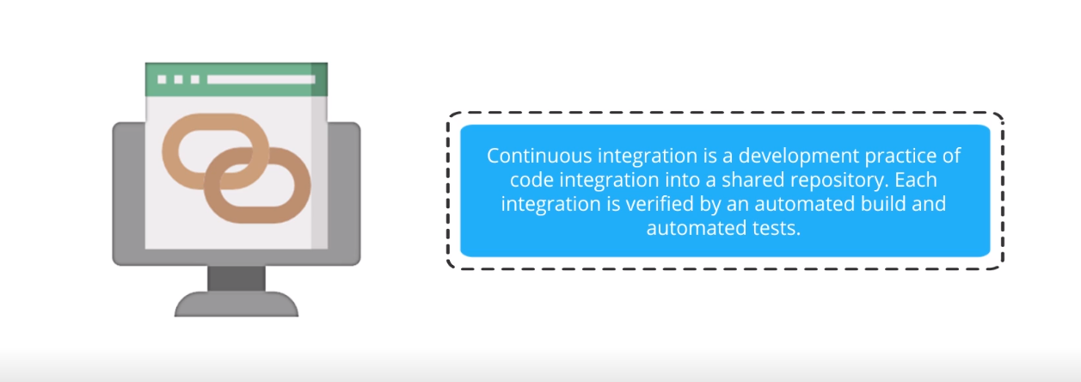

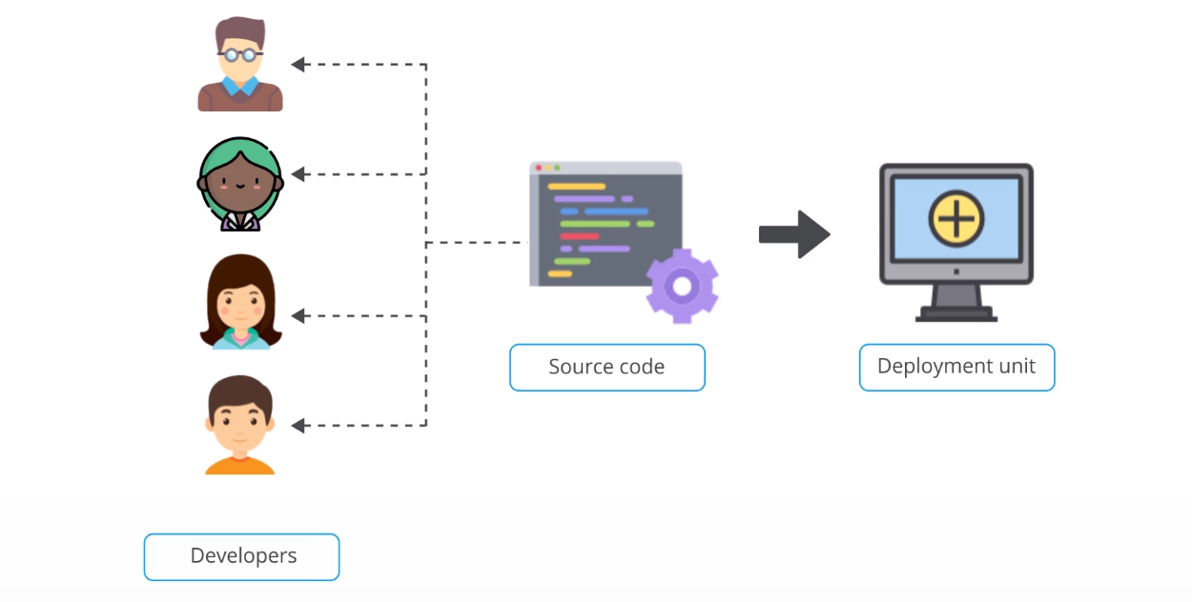

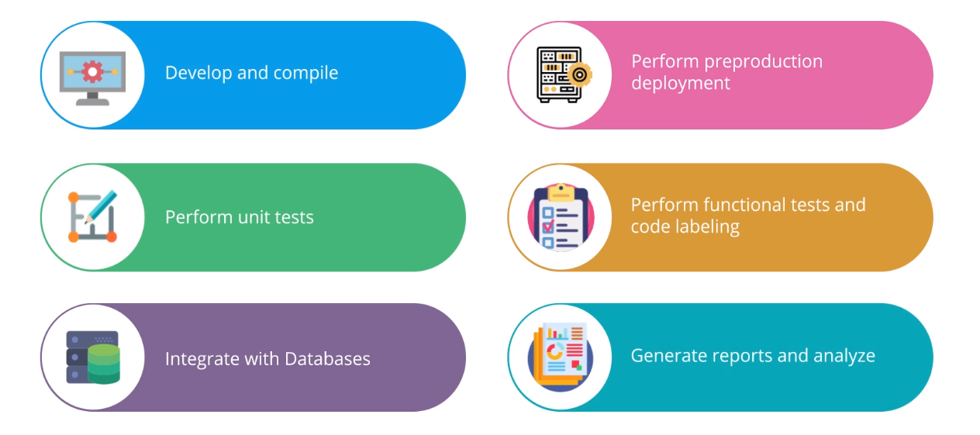

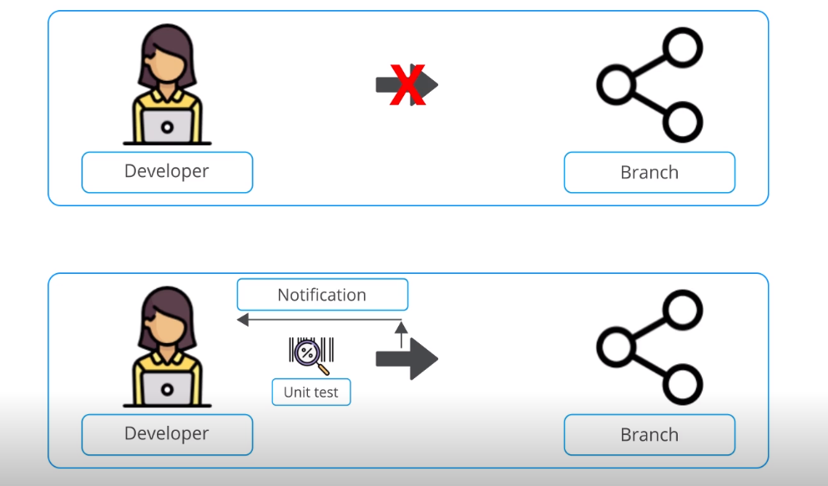

Overview of Continiuous Deployment:

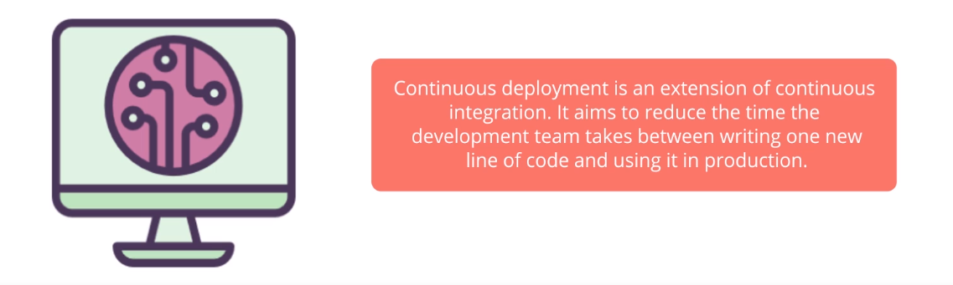

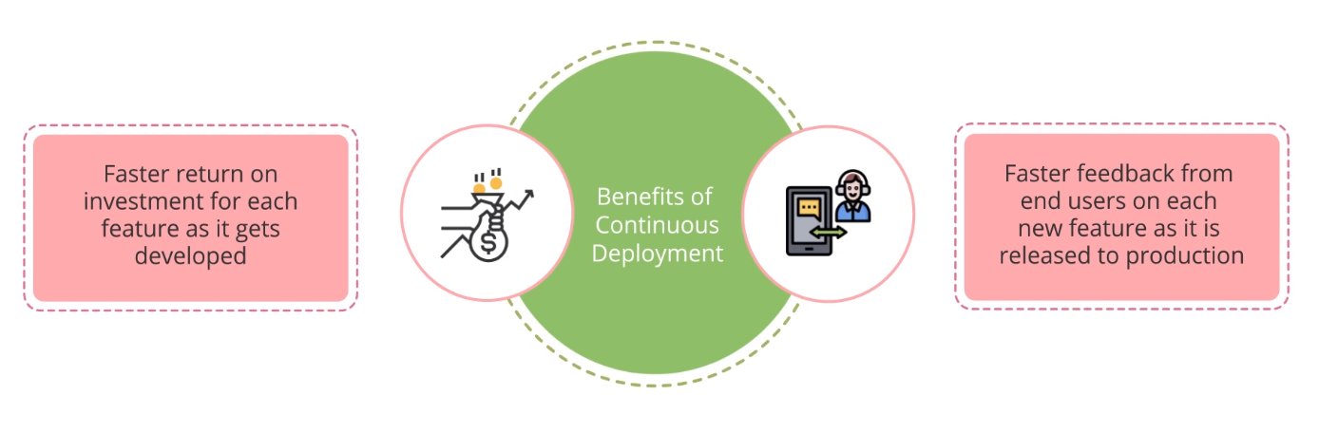

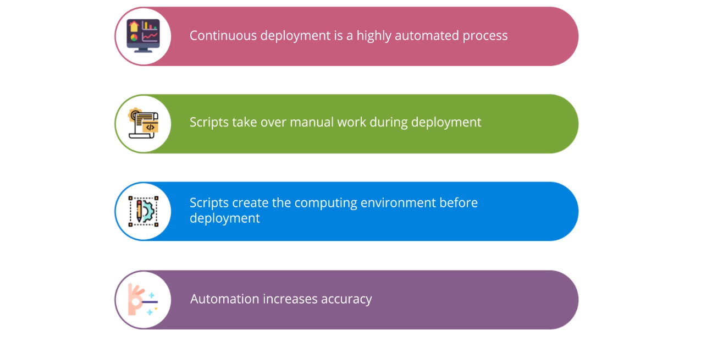

Popular Tools in Continuous Integration and Continuous Deployment:

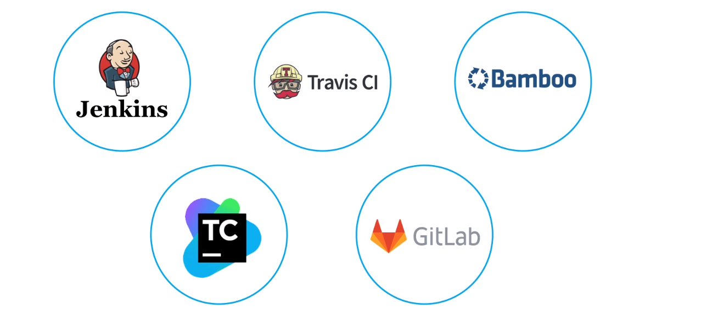

Continuous Integration with Jenkins:

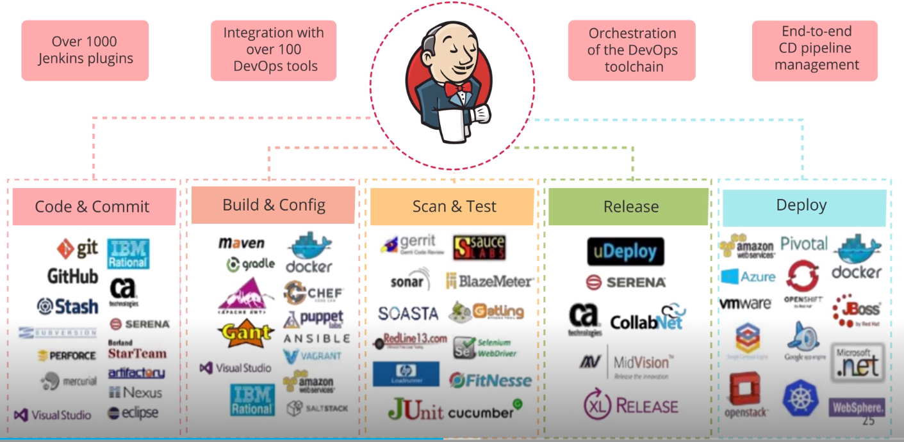

Continuous Deployment with Jenkins:

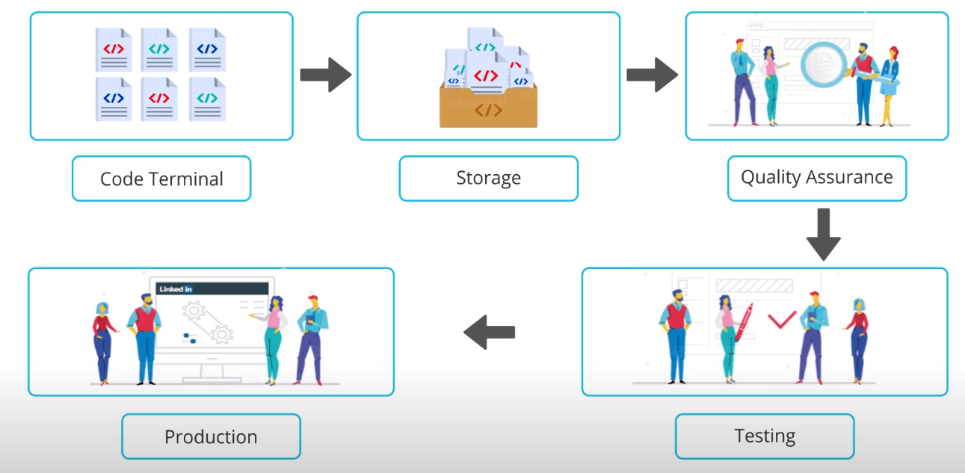



Continuous Integration with TeamCity:

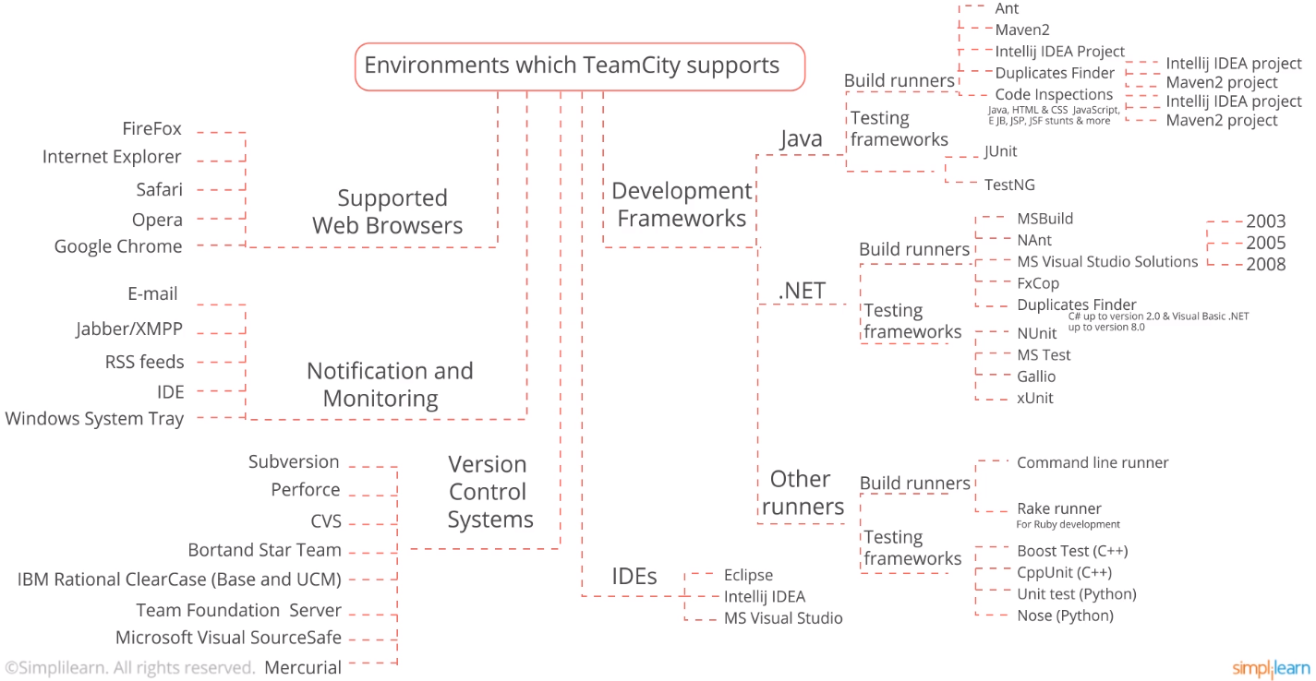

Continuous Deployment with TeamCity:

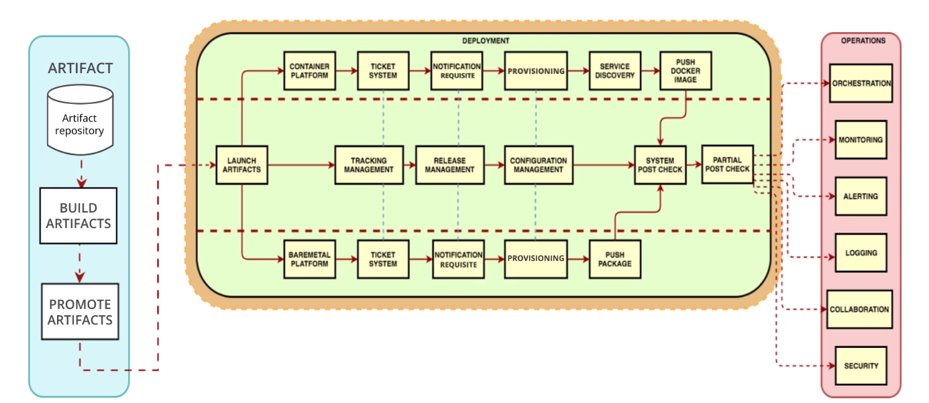

**4.3 Overview and Features of Jenkins**

Jenkins as a Continuous Integration Tool:

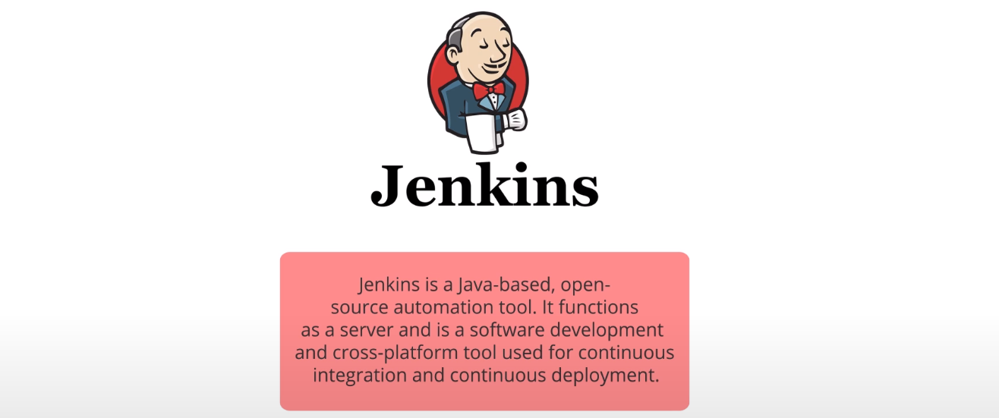

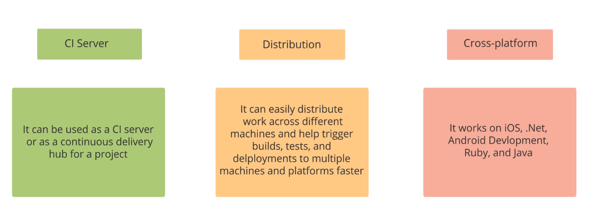

Architecture of Jenkins:

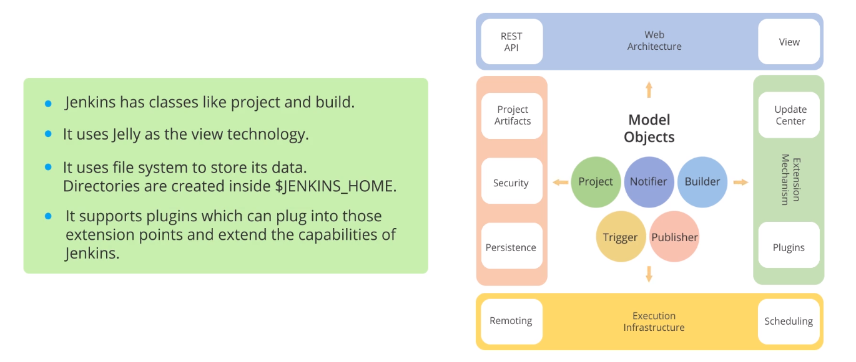Popular Features of Jenkins:

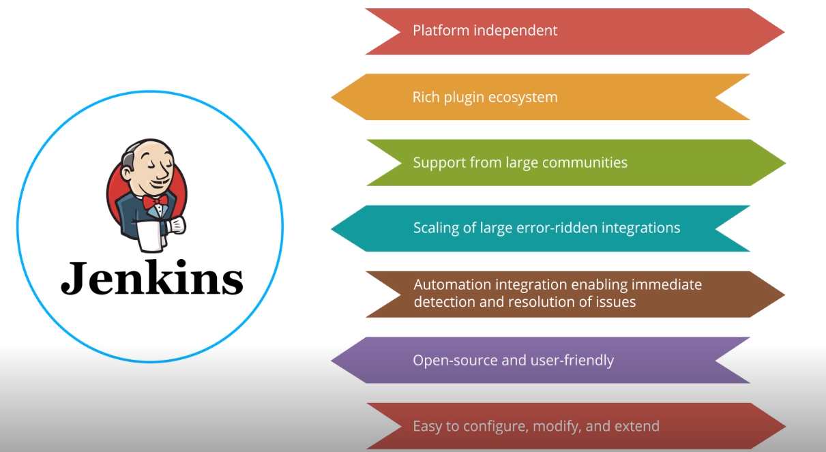

Build Status and Job Health:

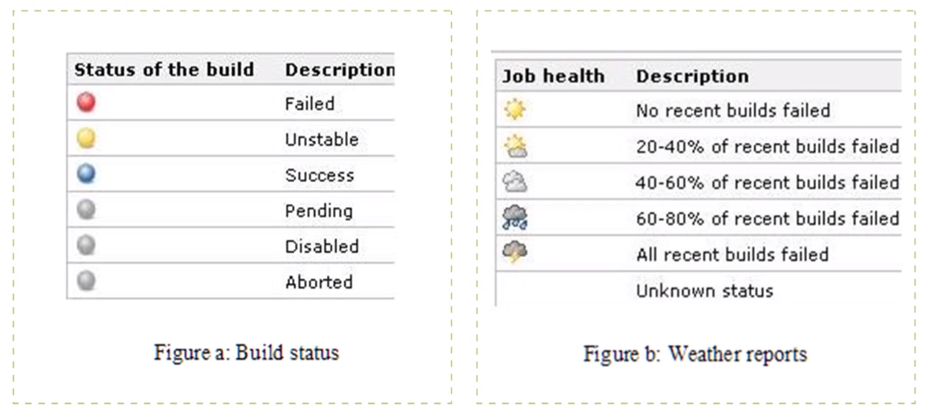

**4.4 Set up Jenkins**

Praxisbeispiel

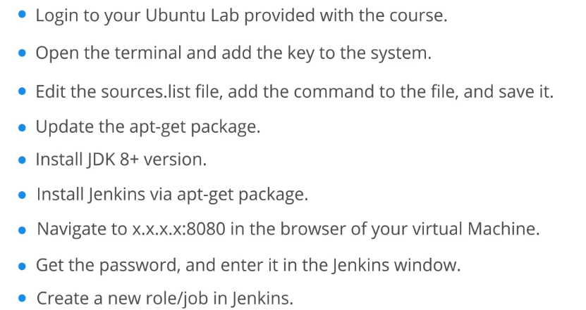

**4.5 Overview and the Features of TeamCity**

TeamCity as a Continuous Integration Tool:

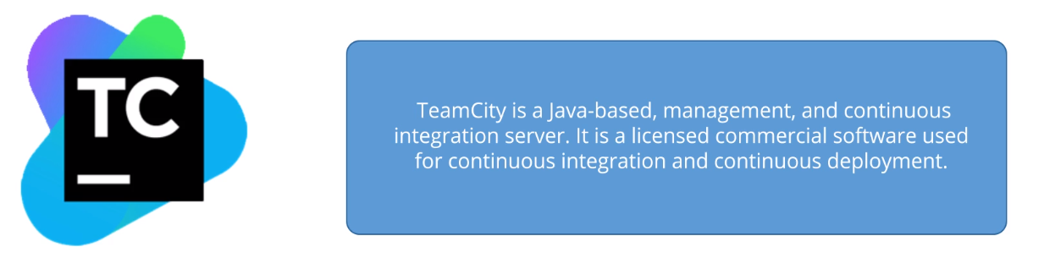

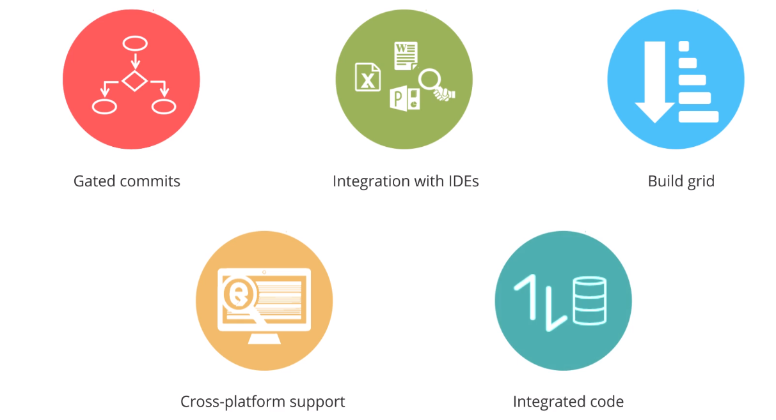

TeamCity Workflow:

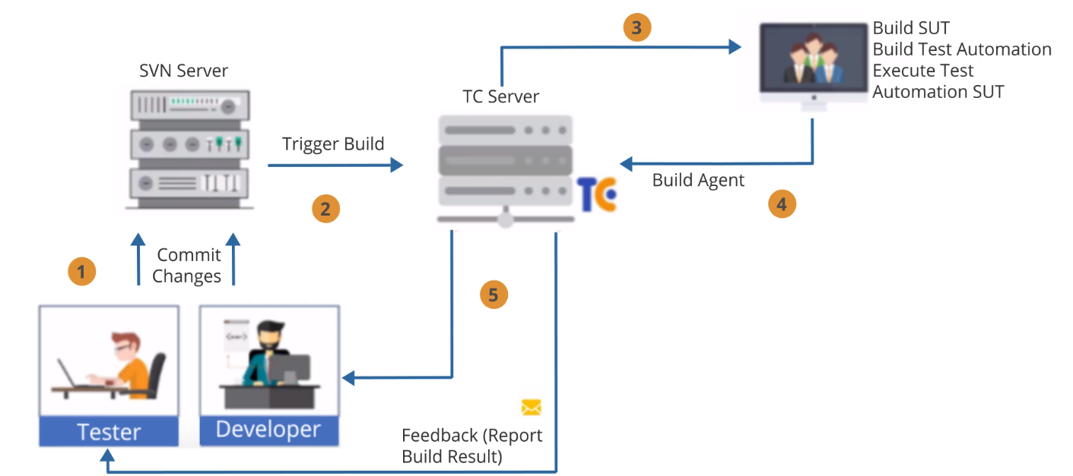

Popular Features of TeamCity:

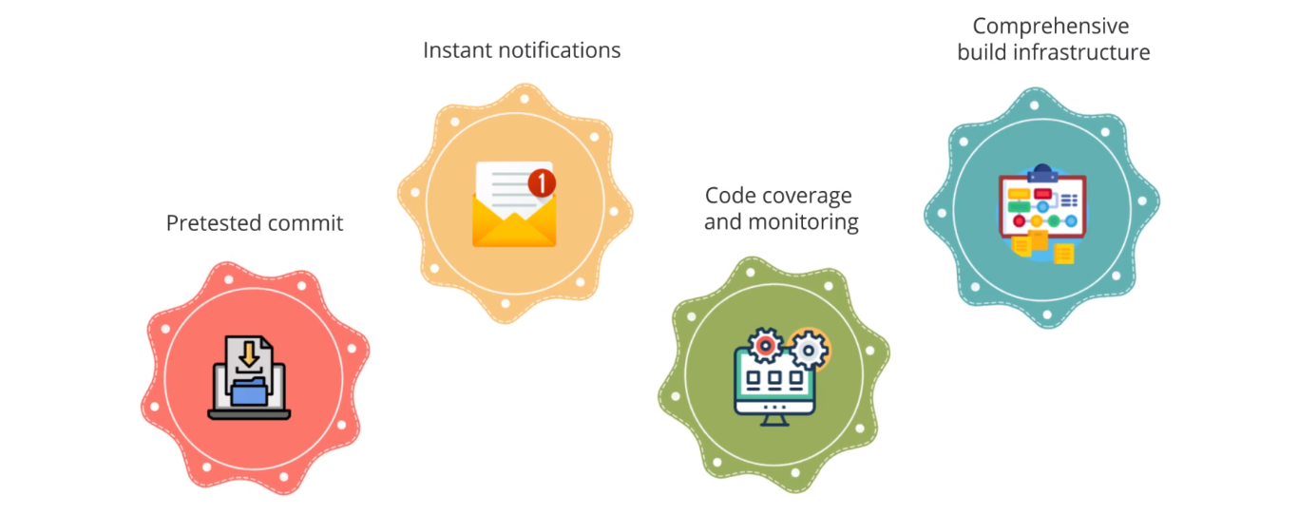

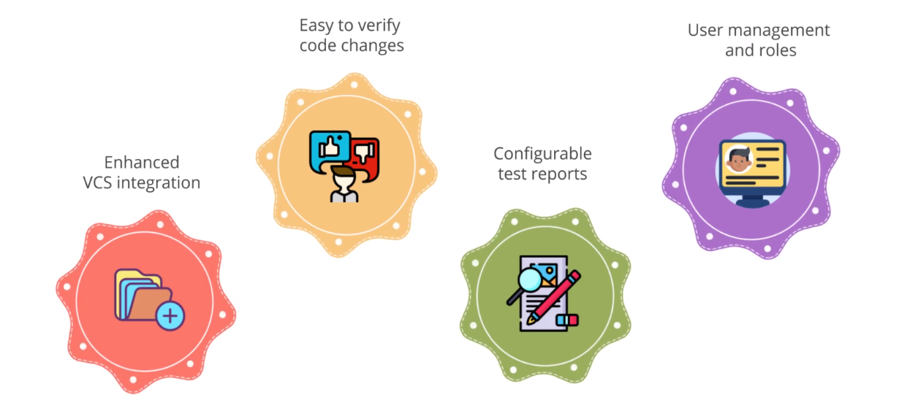

**4.6. Set up TeamCity**

Praxisbeispiel:

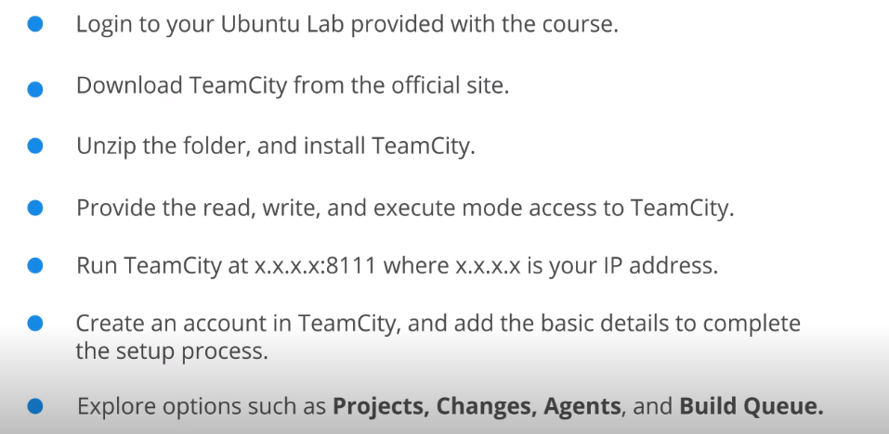

**4.7 Build Tools and Their Uses**

Build Tools:

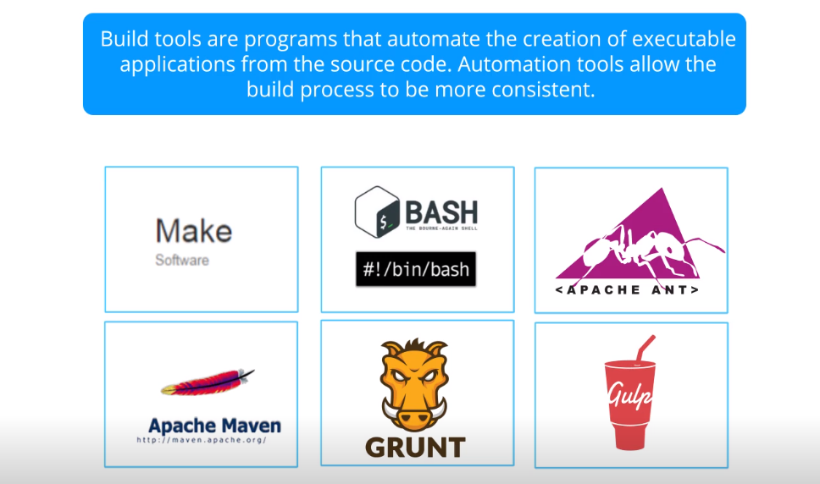

Popular Features of Build Tools:

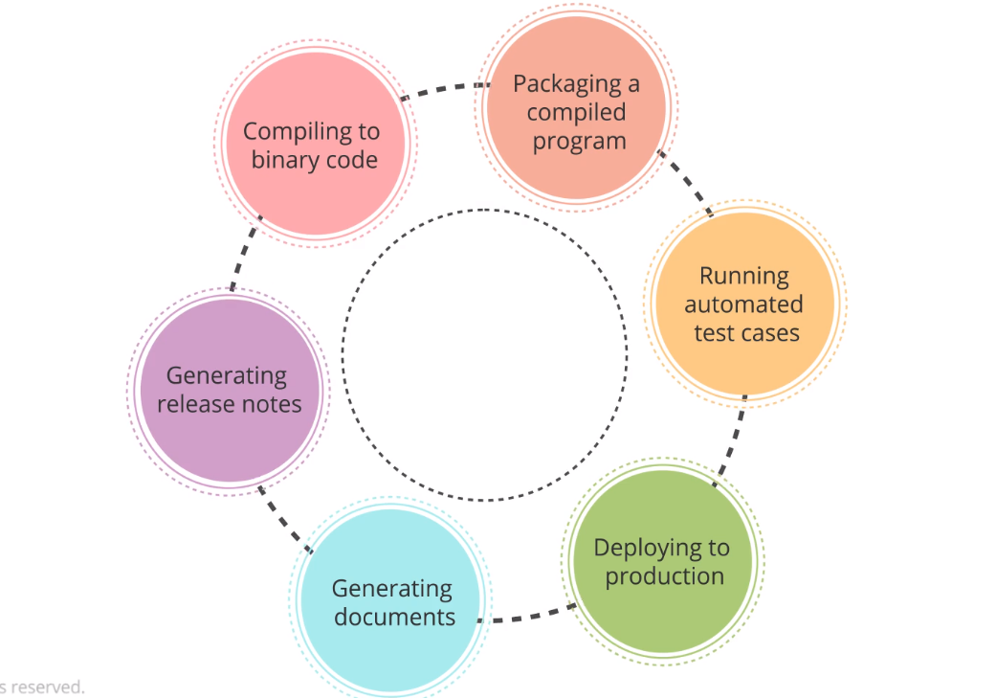

Overview of Apache Ant:

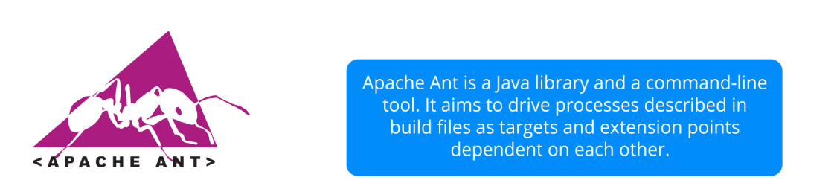

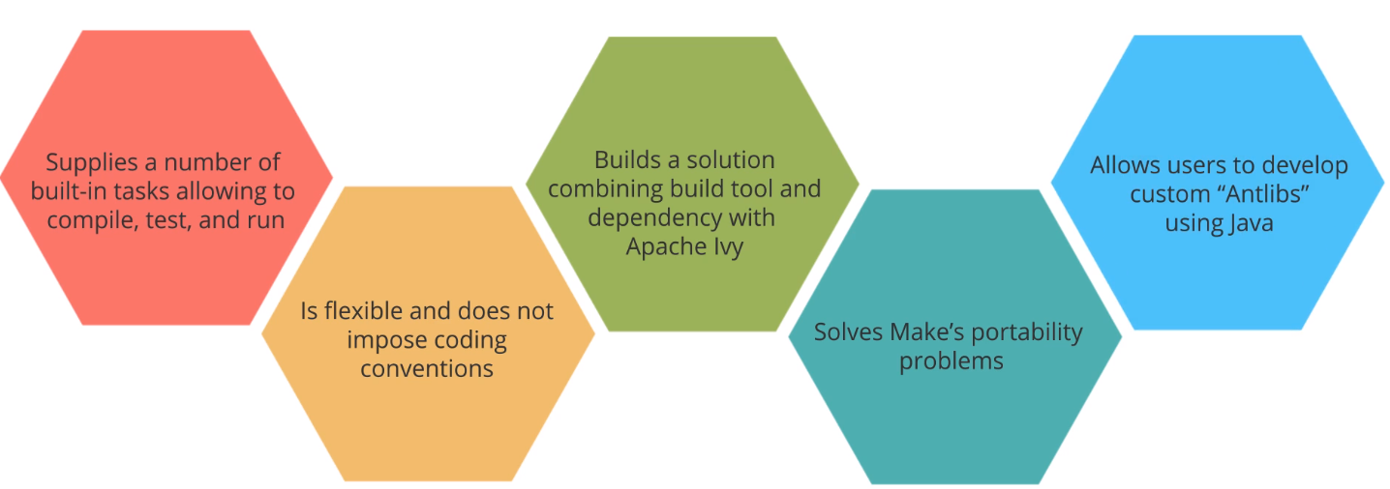

Limitations of Apache Ant:

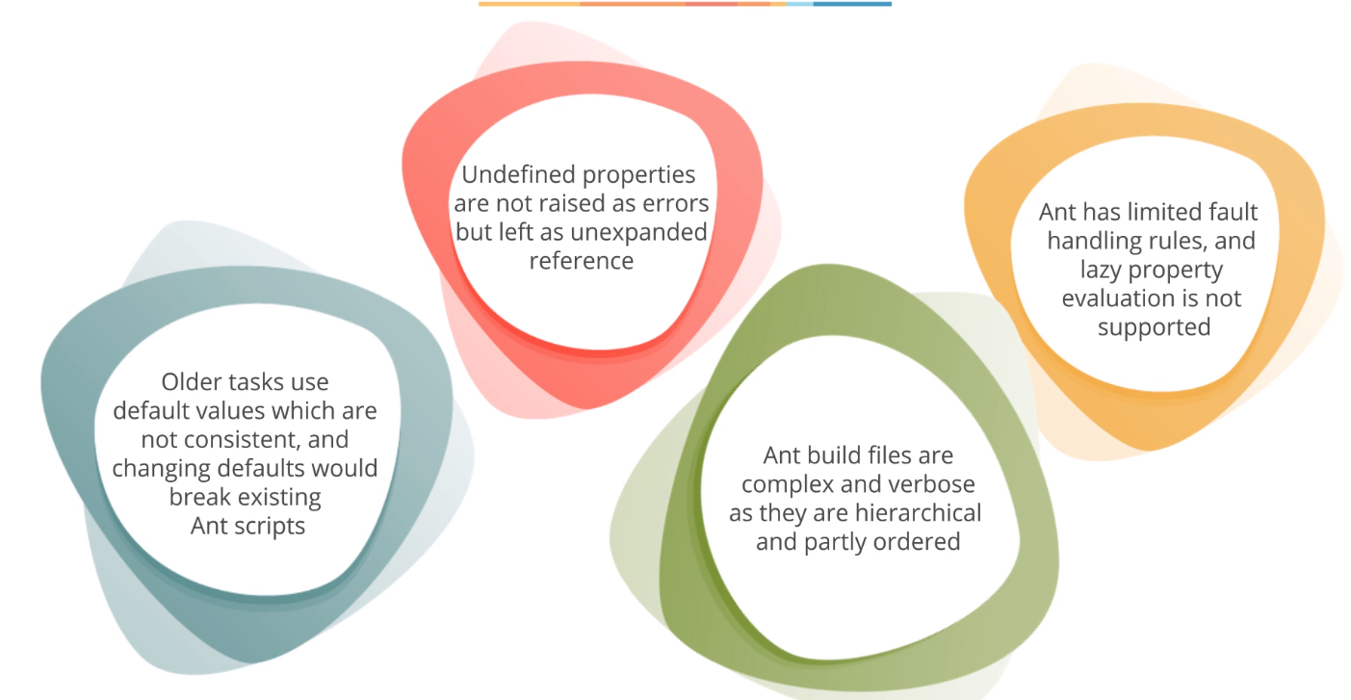

Overview of Maven:

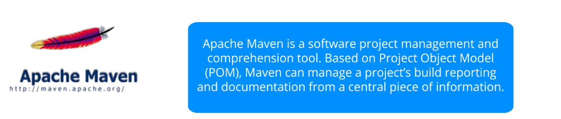

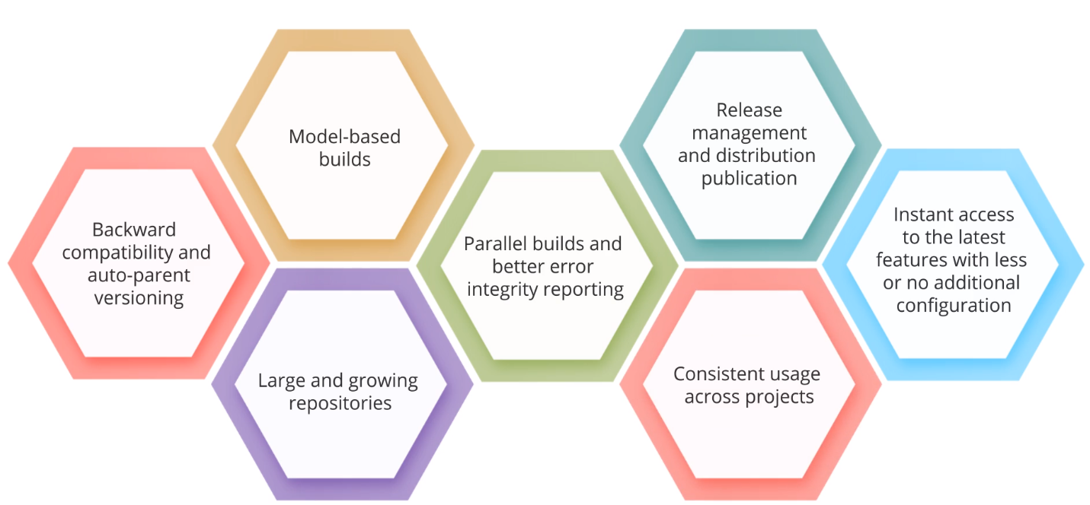

Drawbacks of Maven:

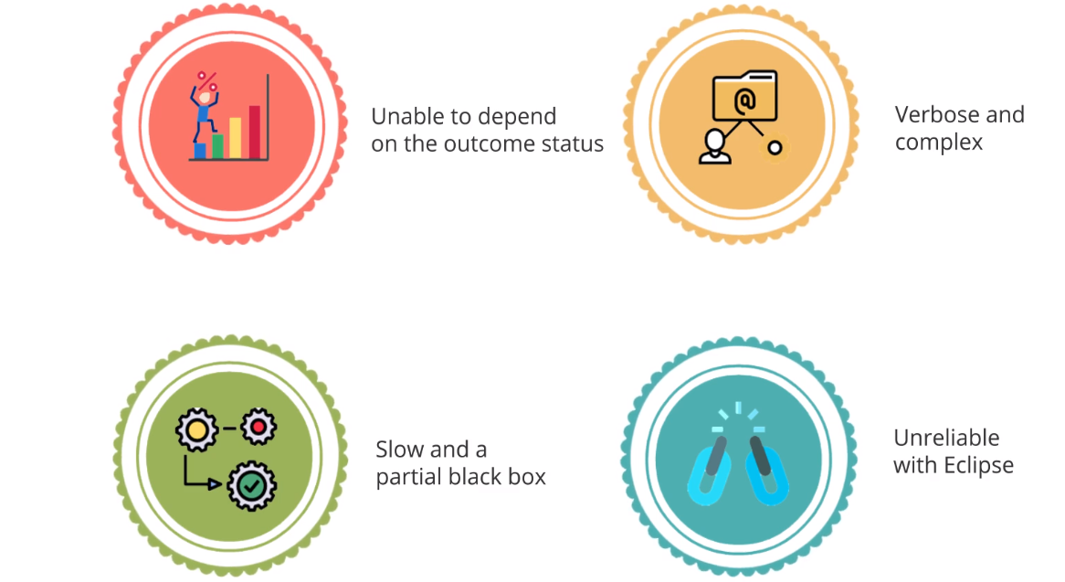

Maven over Ant:

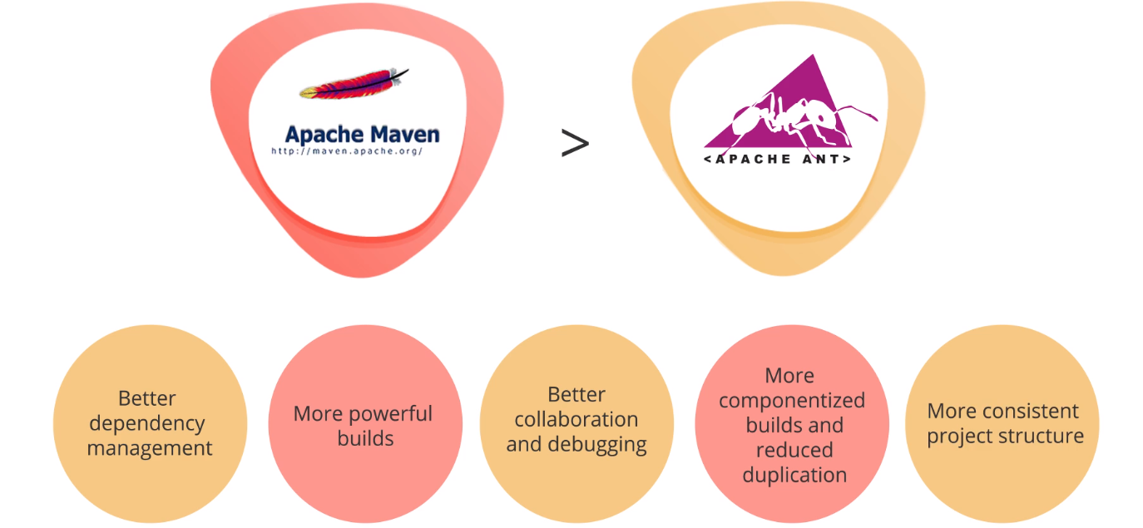

Project Object Model (POM):

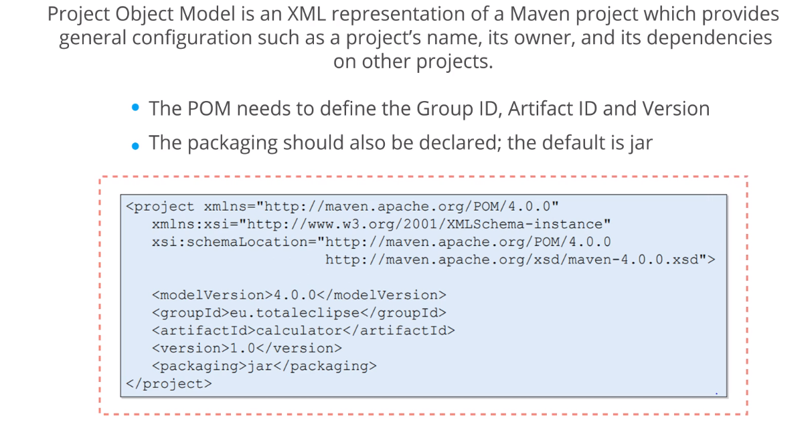

Overview of Grunt:

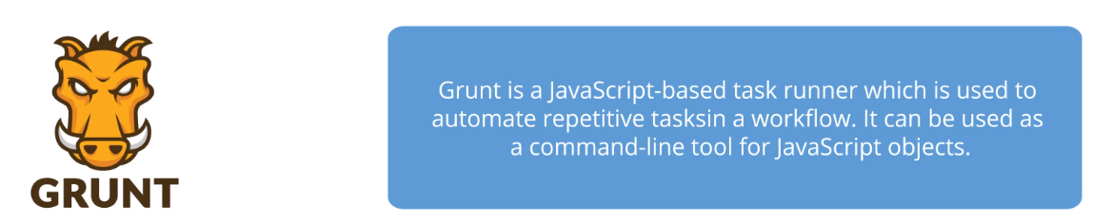

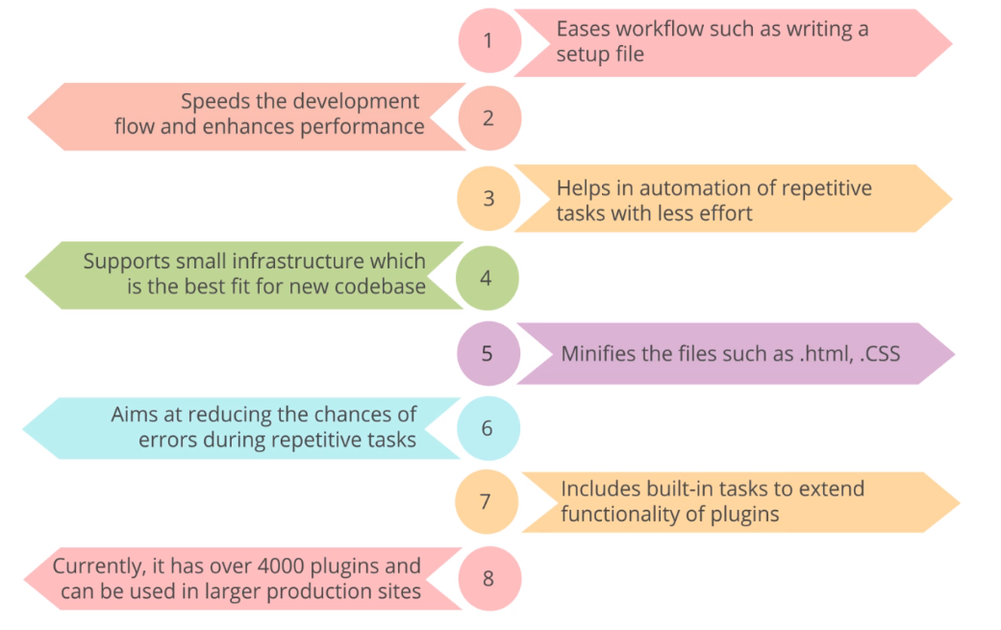

Overview of Gulp:

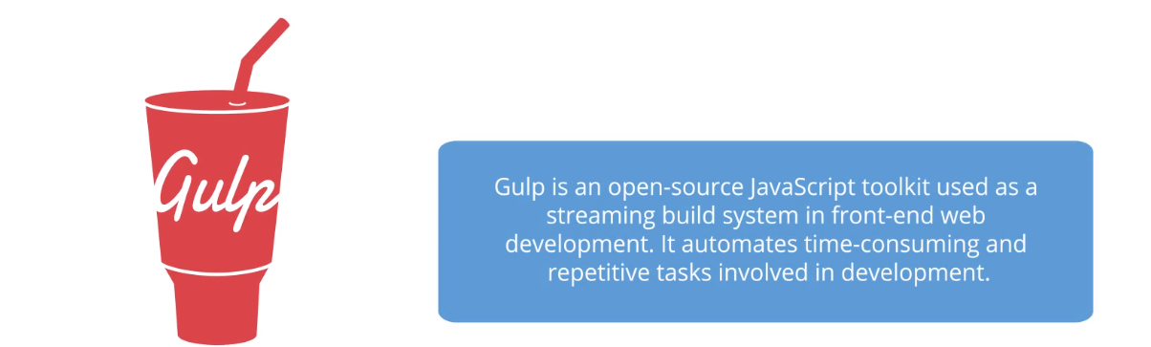

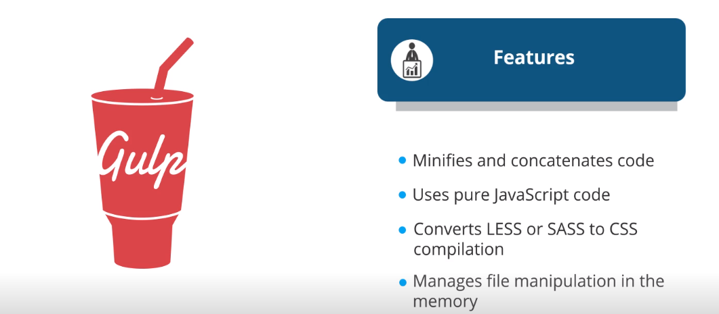

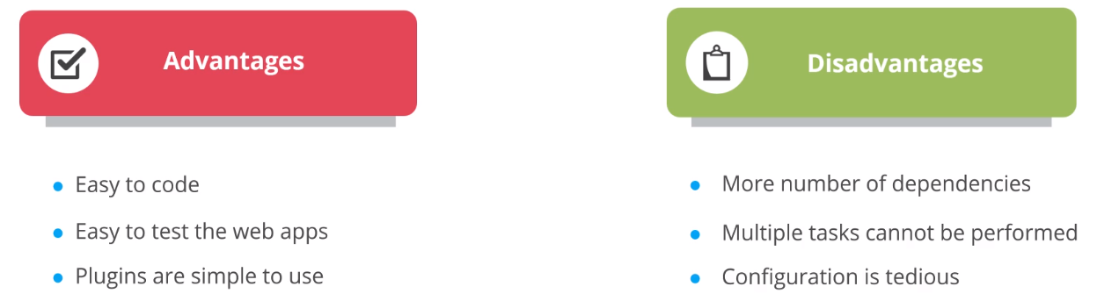

**4.8 CI with Jenkins and Maven**

Praxisbeispiel

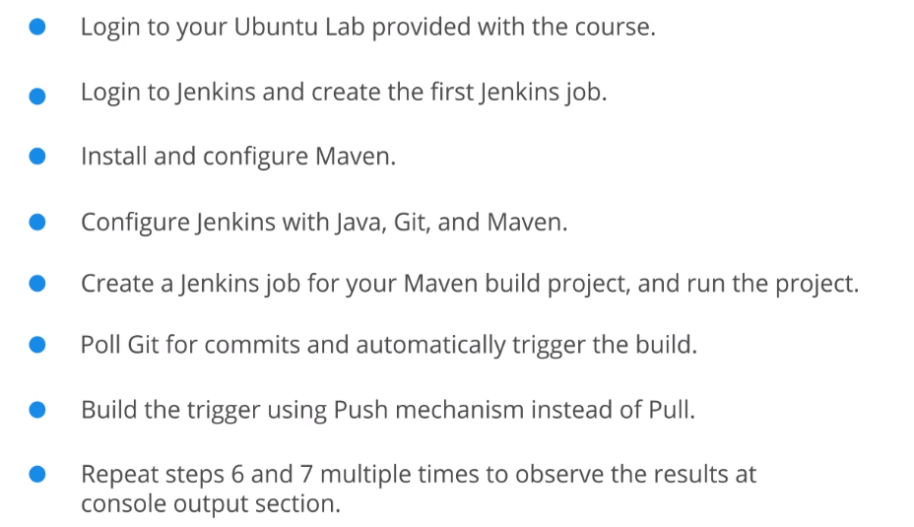

**4.9 Key Takeaways**

